Sales Performance Analysis

- Objective
The objective of this project is to analyze Superstore sales data, identify sales trends and high-performing products, evaluate regional performance, and generate actionable business insights using Python and Tableau.

- Dataset Information
Dataset Name: Superstore Sales Dataset
Source: Kaggle
Dataset Description:
- The dataset contains sales transaction records from a retail superstore.
- It includes information about customer orders, products, sales, shipping details, and geographical regions.
- The dataset is used to analyze sales performance, identify trends, compare regional sales, and determine top-performing products.
Key Columns Used:
- Order ID
- Order Date
- Ship Date
- Customer ID
- Customer Name
- Region
- State
- Category
- Sub-Category
- Product Name
- Sales
Total Records: 9800
Total Columns: 18

- Data Cleaning

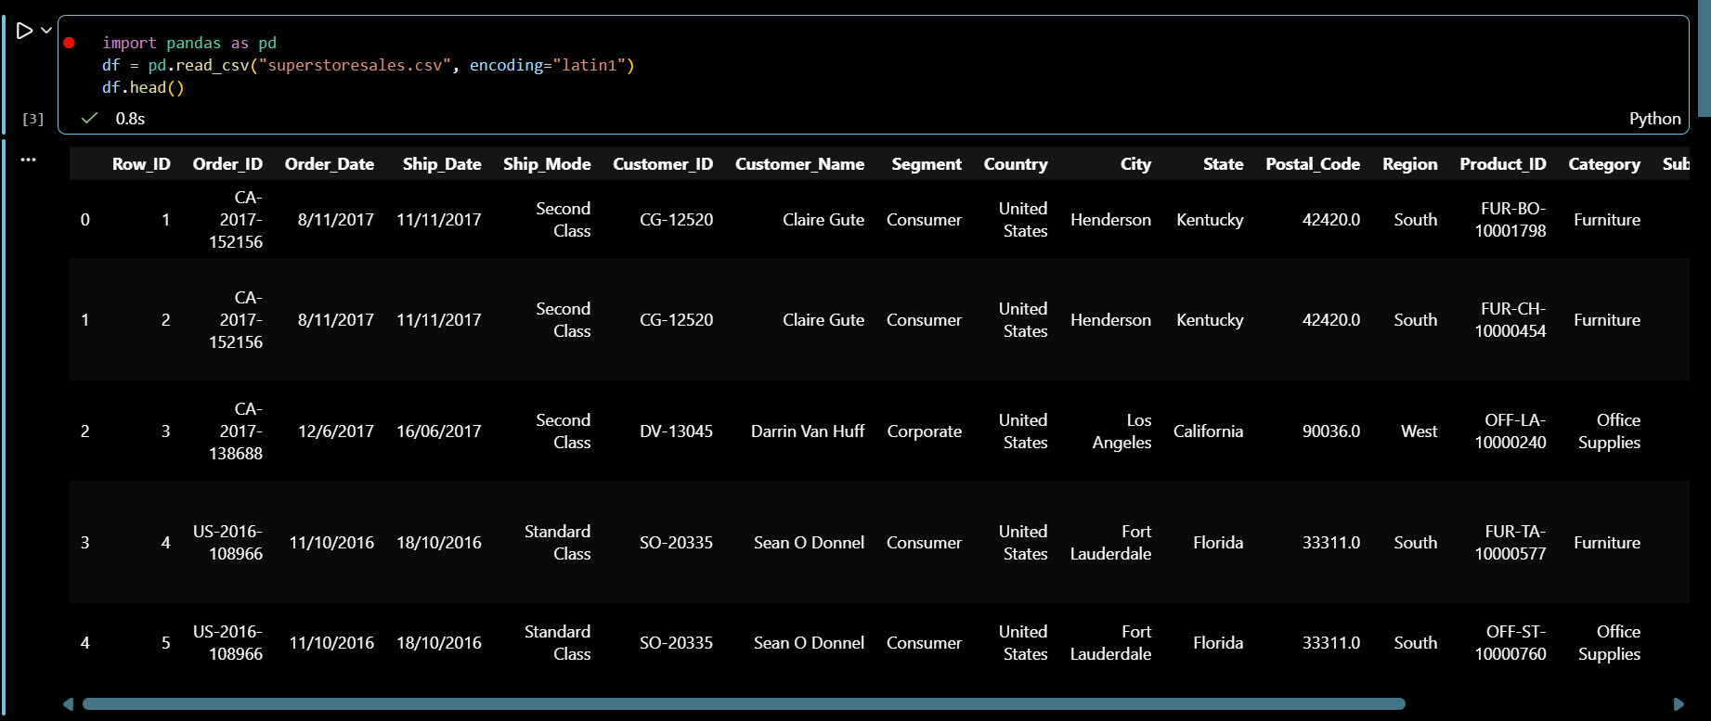
Figure 1:Dataset Preview

Observation
- The first five records of the dataset were displayed successfully.
- The dataset contains customer, order, product, shipping, and sales information.
- The data appears to be properly structured and ready for analysis.
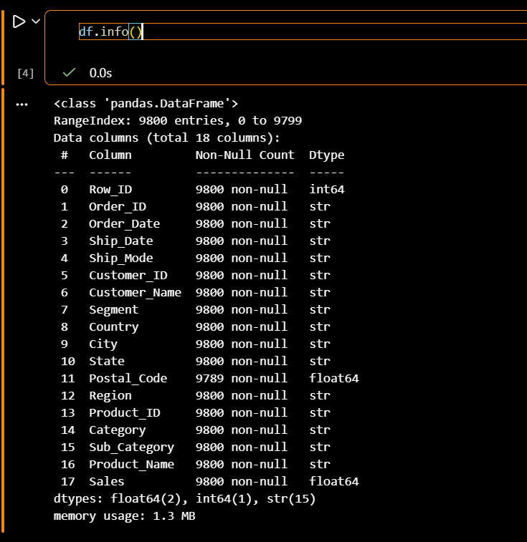
Figure 2:Dataset Information

Observation
- The dataset contains 9,800 rows and 18 columns.
- Most columns are of string (object) data type, while Sales and Postal_Code are numeric.
- Only the Postal_Code column contains missing values (11 records), whereas all other columns are complete.
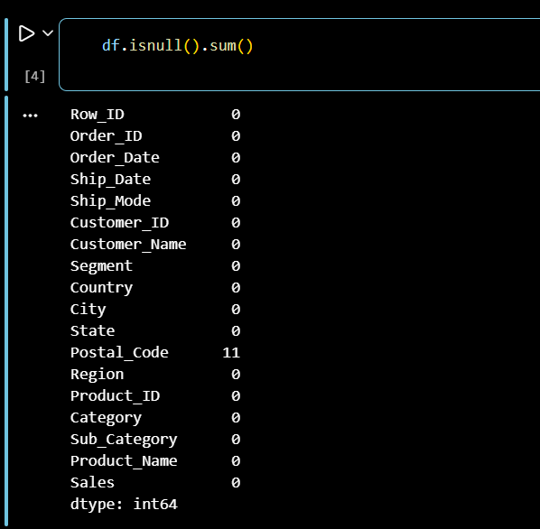
Figure 3:Missing Values

Observation
- Missing value analysis shows that only the Postal_Code column has 11 missing values.
- All remaining columns have no missing values, indicating good overall data quality.
- Summary Statistics

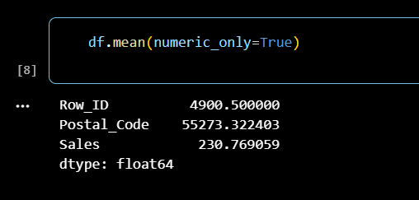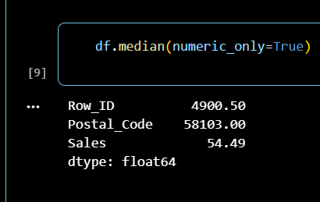
Figure 4:Mean Output Figure 5:Median Output

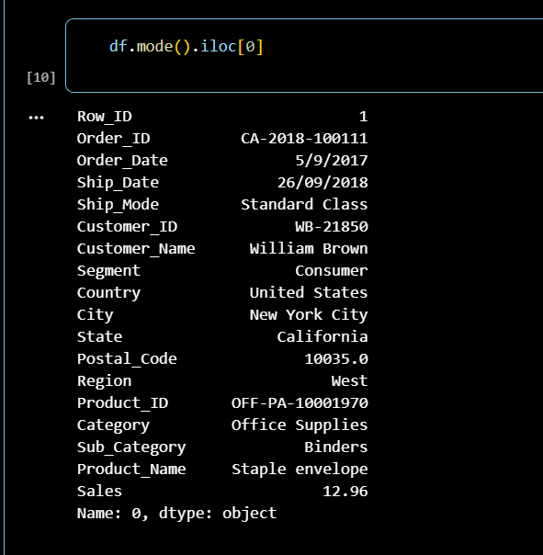
Figure 6:Mode Output
- KPIs
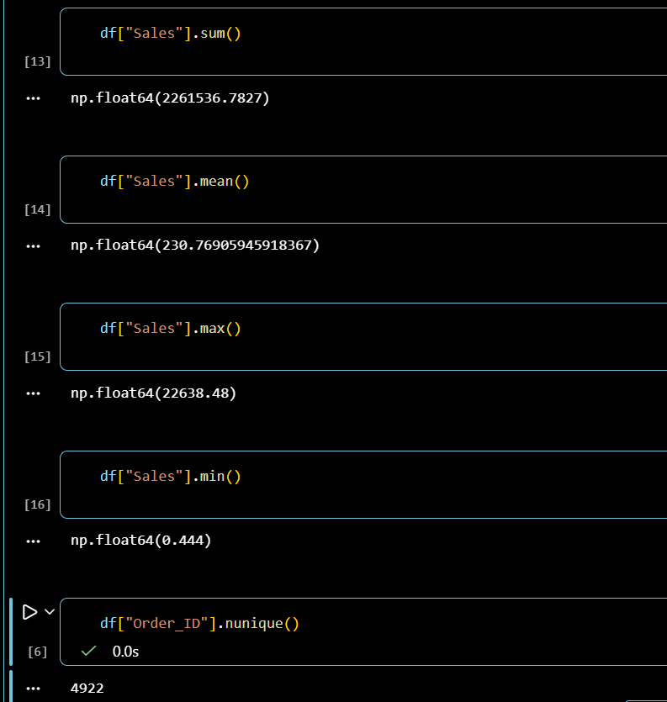

- Visulaizations
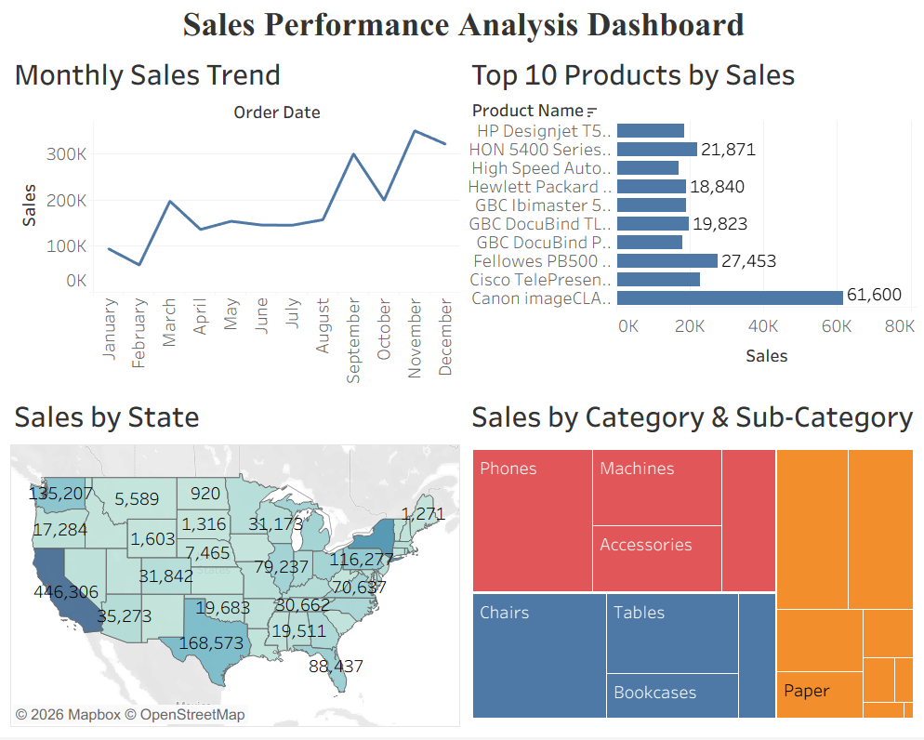
- Monthly Sales Trend
  - Shows monthly variation in sales.
  - Helps identify seasonality and peak sales months.
- Top 10 Products by Sales
  - Displays the products generating the highest revenue.
  - Identifies best-selling products.
- Sales by State
  - Visualizes regional sales distribution across states.
  - Highlights high-performing and low-performing regions.
- Sales by Category & Sub-Category
  - Shows contribution of different product categories.
  - Helps compare category-wise sales performance.

- Executive Summary
The sales analysis of the Superstore dataset reveals that sales vary significantly across products, categories, and regions. Certain products contribute a major share of revenue, while sales are concentrated in a few states. Monthly sales trends indicate seasonal fluctuations, with higher sales observed during the end of the year. The dashboard provides valuable insights that can help improve product planning, inventory management, and regional sales strategies.

- Five Tactical Improvements
• Increase inventory for top-selling products to avoid stock shortages.
• Focus marketing campaigns on low-performing regions to improve sales.
• Promote under-performing product categories through discounts and bundle offers.
• Plan inventory based on seasonal sales trends to meet customer demand.
• Use sales insights to recommend popular products and improve customer purchasing experience.

